**Lab 3**

1. How can you determine the MTU of your network card, and what steps will you follow to accomplish this?

* You can use the command “netsh interface ipv4 show subinterfaces” in the command terminal to show the MTU

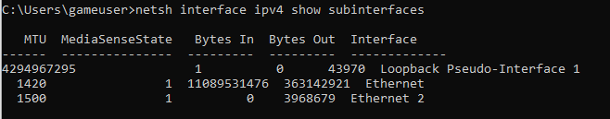

1. Draw an TCP header. Capture packets using wireshark and explain the fields for a particular TCP packet captured. Try to explain the purpose of each field.

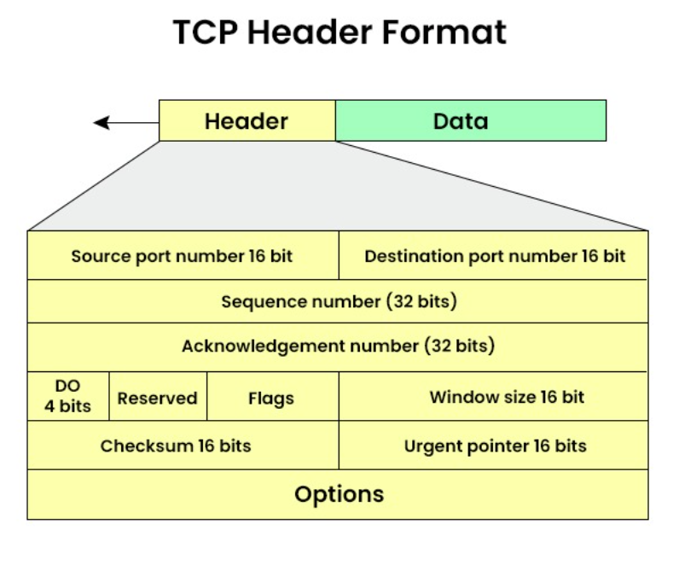

293 (01111011 01111011)

16 (00000001 00100101)

5 (0101)

565 (00000000 00000000 00000010 00110101)

1 (00000000 00000000 00000000 00000001)

N/A

0

0x7b7b (01111011 01111011)

0

56801 (11011110 00000001)

443 (00000001 10111011)

* **Source Port**: Port number of sender’s source
* **Destination Port**: Port number of receiver’s source
* **Sequence Number**: Keeps track of bytes sent over
* **Acknowledgement Number**: Tells sender the number of bytes it has received
* **Data Offset**: Length of TCP header
* **Reserved**: Bits reserved for future use
* **Flags**: Flags manage connection, setup, teardown and data transmission. There is 9 in total.
* **Window Size**: Indicates how much bites the receiver can receive before the sender must wait for acknowledgment
* **Checksum**: The checksum is used for error-checking of the header and data.
* **Urgent Pointer**: Indicates whether a package is urgent or not.
* **Options**: Allows additional settings

1. Draw an UDP header. Capture packets using wireshark and explain the fields for a particular UDP packet captured. Try to explain the purpose of each field.

-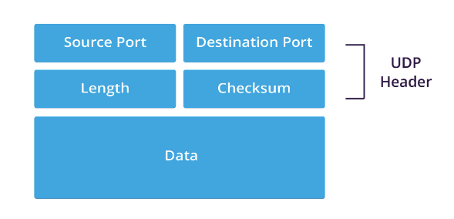

62761 (1111011011111001)

443 (110110011)

0

40 (101000)

- **Source Port**: Indicates the port number of the sender

- **Destination Port**: Indicates the port number of the receiver.

- **Length**: Specifies the total length of the UDP packet

- **Checksum**: Error-checking for integrity